# Actuator health issue.

## Problem: For our application actuator/health was not working and it was giving internal server error.

Description:   
  
In our application we had all the dependencies related to actuator. (spring starter actuator).   
For circuit breaker and retry operations we used Resilience 4j .   
  
The app was building successfully and we were able to run. All actuator end points were working well except actuator/health. It was weird because /actuator , /actuator/info, /actuator/threaddump were giving results.  
  
When I triggered /actuator/health the response was like this. It was giving NoSuchFieldError and meant Actuator class/bean doesn’t have any filed such as health.  
  
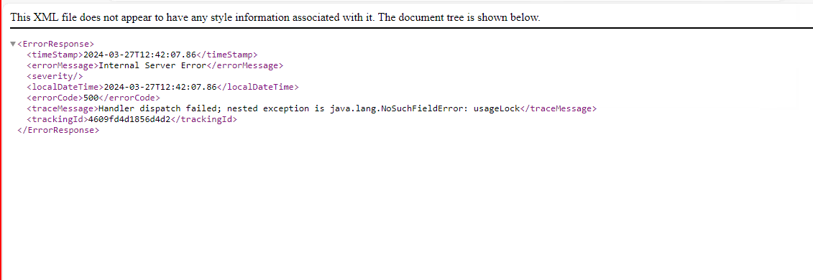

I tried so much in the internet but was not able to fix the issue.   
I got a doubt on resilience 4j dependencies and downgraded the dependency from 1.7.0 to 1.3.1 and it didn’t work and it was showing this error while starting the app.  
  
In the above error it was clearly indicating that some issue is there with actuator health dependency. This was nothing to do with actuator dependency but with the resilience 4j dependency.

So I tried to upgrade and downgrade the resilience 4j dependencies   
  
implementation "io.github.resilience4j:resilience4j-spring-boot2:$resilience4jVersion"

    implementation "io.github.resilience4j:resilience4j-circuitbreaker:$resilience4jVersion"

    implementation "io.github.resilience4j:resilience4j-timelimiter:$resilience4jVersion"

    implementation "io.github.resilience4j:resilience4j-micrometer:$resilience4jVersion"

    implementation "io.github.resilience4j:resilience4j-retry:$resilience4jVersion"

but it didn’t help and they rather triggered another dependency mismatch with spring fox and open api doc dependency and also log back dependencies.

So I started comparing another app and figured out our app had an extra dependency i.e   
  
implementation "com.fedex.mwa:activemq-client:5.8.0"  
  
I removed it and everything went well and even actuator/health was giving the desired results.  
  
Conclusion: Dependency mismatches errors you won’t find internet most of time and you will get little hints from stack over flow.

Always also be careful with resilience 4j dependencies and open api /sprng fox dependencies